Brandon Middle School  1:1 Technology Policy  Rankin County School District (RCSD)/ Brandon Middle School (BMS) provides laptops to students in grades 7-8th enrolled at Brandon Middle School. Students must pay a yearly $50.00 fee to use laptops. Student use of laptops and school network is a privilege, not a right. Students must follow all student computer rules and regulations. Laptops are the property of the RCSD and RCSD personnel reserve the right to monitor and inspect all laptops and Internet activity at any time. Periodic checks of browser history and Internet usage may be conducted. Students have no right to privacy on RCSD laptops.  - RCSD/BMS assumes no responsibility for any charges made by students using an RCSD computer or violation of copyright laws.  - Student security is a priority. Students shall not give out personal information through the Internet. This includes but not limited to, student user name, password, address, phone number, and photos. Students should contact school personnel if they are contacted inappropriately or receive photos in violation of the established guidelines.  - Students shall not attempt to make any repairs to the computer. Any problems or issues must be reported by filling out a student technology work order on the BMS website. |  | 2019-20  MacBook  Accessory  Pricelist  (Prices subject to change)  ________  *Neoprene Sleeve  $30.00  ________  *Power Cord $71.00  ________  *Protective Clear hard shell  3 free replacements over the course of the life of the laptop or 1 a year.  $10 after the 3rd free shell  [Web Address]

Computer Use and Care

- No food or drink should be around the computer at any time.
- Laptops must be equipped with the clear shell at all times and must be carried in the black RCSD sleeve, even if student carries a backpack. Sleeve can be placed inside the backpack.
- Students are responsible for computer and charger at all times. Laptops and accessories should not be left unattended.
- Music, videos, games, and pictures that are not required for coursework are not to be downloaded and/or saved on the computer.
- Internet searches and downloads should only be for school related coursework.
- Outside email and message services are not allowed.
- Accessing, submitting, downloading, scanning, publishing, forwarding, posting, or displaying any material that is obscene, vulgar, sexually explicit/suggestive, threatening, discriminatory, and/or illegal is prohibited.
- Plagiarism of any work is prohibited.
- Neglect, malicious use, and/or vandalism of laptops and/or school network is prohibited.
- Laptops must be fully charged each day.
- Do not allow other students to use your computer or charger.
- Laptops should be shut down when not in use.
- Students will have access to social networking sites after school.

Tips for Parents
Parents are encouraged to:
- Set and enforce rules for home Internet use
- Have computer in a common room
- Set a time limit on Internet, instant messaging, social networking sites, online gaming, etc.
- Ask and know student’s personal username and password
- Have a curfew for computer use. Place the computer in a common area to charge overnight.
- Have access to students’ e-mail
- Monitor messages sent
- Monitor their child’s activities on social networking sites and ensure that private data is not posted online.

Brandon Middle School Technology Consequences

Inappropriate content
(includes inappropriate internet searches, pictures of guns, alcohol, tobacco products, vulgar language, inappropriate conversations in messages and/ or emails, etc.)

1st offense: 1-day ISS and one week of computer probation, which includes the loss of home computer privileges.
2nd offense: One day suspension and two-week computer probation, which includes the loss of home computer privileges.
3rd offense: Multiple day suspensions and one-month computer probation, which includes the loss of home computer privileges.
**Anything beyond the 3rd offense may result in additional suspensions and computer probation up to the end of the school year, which includes the loss of home computer privileges.

Inappropriate photographs and/or explicit content
(includes nude photos, pornography

1st offense: 2-day suspension and one-month computer probation, which includes the loss of home computer privileges.
2nd offense: 4-day suspension and one-month computer probation, which includes the loss of home computer privileges.

Inappropriate photographs or content AND distribution to others

Multiple day suspensions and/or expulsion and loss of computer privileges (reviewed on a case to case basis)

Negligence of computer

(includes but is not limited to writing on the computers, stickers or tape, dirt, accidental neglect, or missing accessories)

1st offense: 24-hour computer probation, computer taken for inspection and correction of infraction(s)
2nd offense: one-week computer probation and loss of home computer privilege
3rd offense: two weeks computer probation and loss of home computer privilege

Purposeful mistreatment of computer that results in damages
(This includes hacking into the computer filter or systems)

1st offense: up to 3-day suspension, full cost of repair, and two weeks probation, which includes the loss of home computer privilege.
2nd offense: up to 5-day suspension, full cost of repair, and one-month probation, which includes the loss of home computer privilege.

Inappropriate Use of Computer during the school day

(includes, buts (Includes but is not limited to noncompliance with teacher directives in regards to computer use: playing games, listening to music, chatting with others via email or chat, watching videos, etc.)

1st Offense: 24-hour computer probation, which includes loss of home computer privilege and morning detention assigned by the teacher
2nd Offense: One-week computer probation, which includes loss of home computer privilege and disciplinary action assigned by the administrator
3rd Offense: Two weeks computer probation, which includes loss of home computer privilege and disciplinary action assigned by the administrator
4th Offense: One-month computer probation, which includes loss of home computer privilege, and out of school suspension
**Additional offenses could result in permanent loss of computer privileges
*** days are defined as school days, not calendar days to include weekends and holidays

Fees for damaged devices

The following fees are associated with the actual device. Loss, theft, and damages to power cords, neoprene sleeves, and clear shells are considered damaged accessories. The $50 insurance fee does not cover computer accessories. These items must be purchased separately (see the pricelist on page 1)

Any damage to electronic devices must be reported to school authorities immediately. Whenever a device is submitted for repair, it is important to know the $50 yearly usage fee does not count towards the damage fee. Whenever a damage fee is assessed, students must pay a $50 deductible to cover the device, in addition to any other fees related to the number of damage occurrence. Damage fees do not start over each year. In the event of damage to electronic devices, students will be responsible for providing the deductible to cover the incurred expenses according to the following guidelines:

- First occurrence of damage to the device

  - $50.00 deductible to cover the damage

- Second occurrence of damage to the device

  - $50.00 deductible to cover the damage
  - 25% of the repair cost to cover the laptop
  - Possible loss of take home privilege

- Third occurrence of damage to the device

  - $50.00 deductible to cover the damage
  - 50% of the repair cost to cover the laptop
  - Loss of take home privilege

- Fourth occurrence of damage to the device

- Fair market value to repair or replace the device

Withdrawal Procedures

When students withdraw from Brandon Middle School, they will have to follow these procedures:
- Gather laptop along with all issued accessories: black neoprene sleeve and 2-part power cord (see pictures below). If all the parts of the power cord are not turned in with the laptop, a loss/damage fee of $71 will be assessed to cover the cost of the power cord.
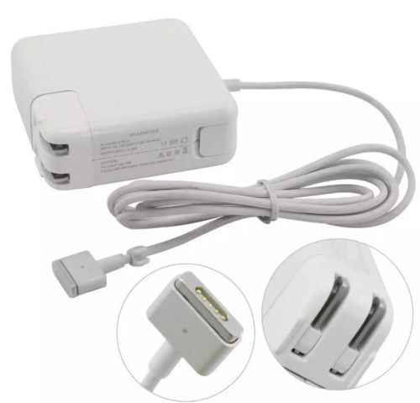
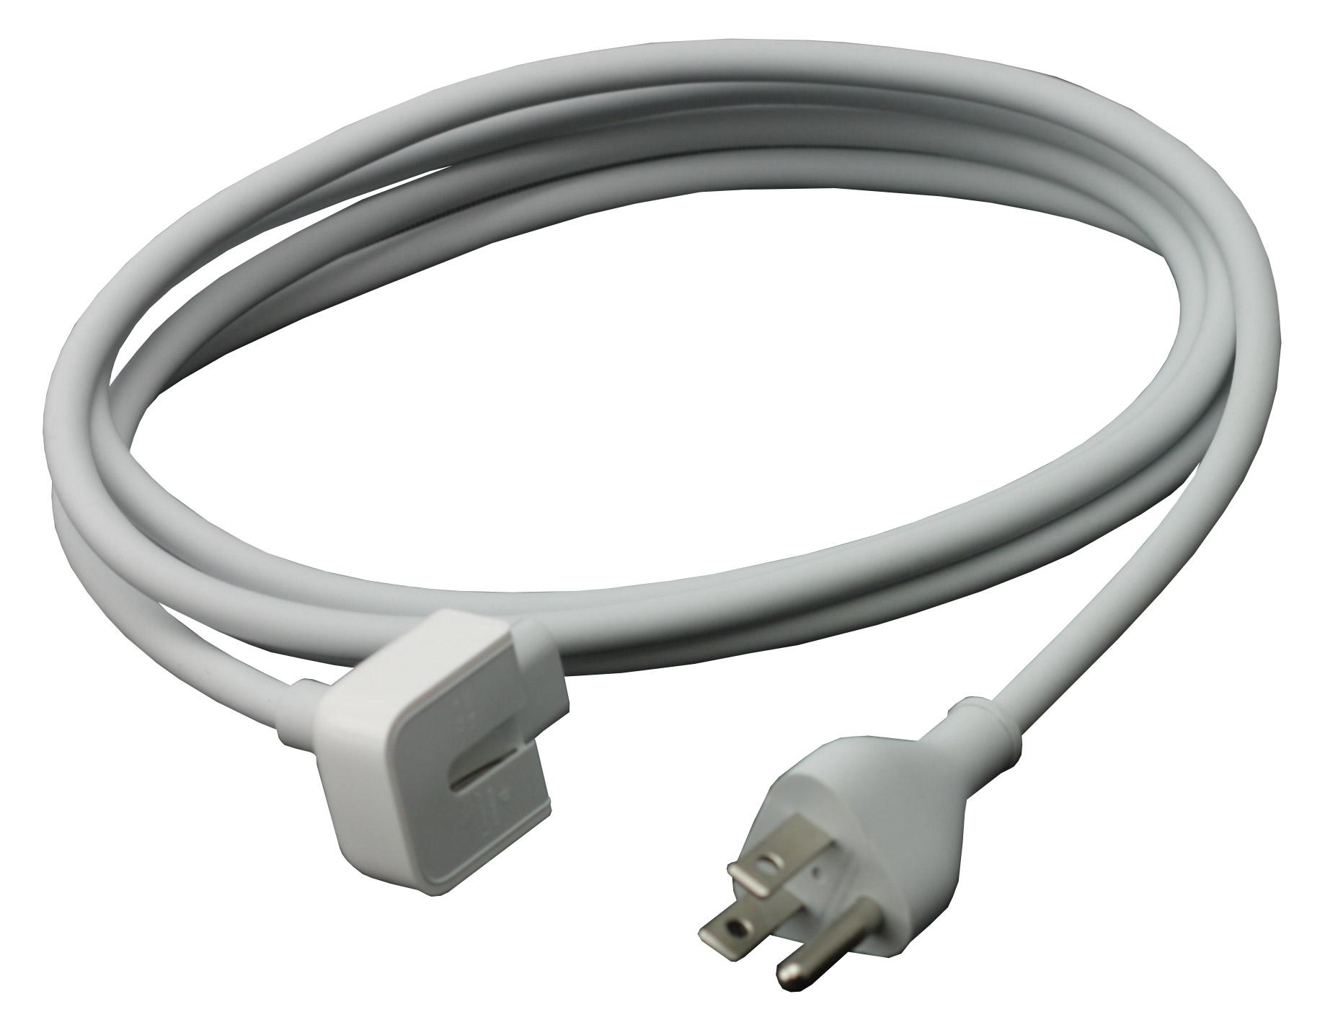

- Make sure the laptop is clean and in working condition.

- Bring the laptop and all accessories to the office of Mrs. Wendy Fletcher for inspection. If any damages are detected or items are lost, fees will be assessed to cover the damages or losses. All fees must be paid in full before students are allowed to withdraw. (See accessory pricelist on page 1)

